

HULL CITY COUNCIL

JOB DESCRIPTION & PERSON SPECIFICATION

SERVICE AREA: | Customer Services | POSITION NO:
SECTION: | Registration Services | GRADE: 3
JOB TITLE: | Registration Assistant | DATE PREPARED: 24.02.15
EVALUATION DATE: | 2 June 2015 | JE NUMBER: NC863
DIGNITY AT WORK: To show, at all times, a personal commitment to treating all Looked after Children and customers and colleagues in a fair and respectful way, which gives positive regard to people’s differences and individuality (for example, gender, gender identity, nationality or ethnic origin, disability, religion or belief, sexual orientation, age). Assists in ensuring equal access to services and employment opportunities for everyone and promotes the Council’s Equal Opportunities in Employment Policy.

PURPOSE:

To support the delivery of the Registration Service.

To provide timely and accurate certified copy certificates of registered life events within the Hull Registration district. This includes both handwritten and electronically produced certificates.

Act as a first point of contact to the service providing a caring, listening service to customers’ which is both responsive to customer requirements, and which recognises the diversity of customer needs.

To become conversant with relevant registration legislation and handbooks

To undertake the role of a deputy registrar registering marriages at the Register Office and other Approved Venues.

To ensure collection and receipting of statutory and non statutory fees and the appropriate recording and control of secure stationary and stock.

PRINCIPAL ACCOUNTABILITIES:
Please note decision making must be included within the Principal Accountabilities
1. | To develop an understanding of the registration service and to become conversant with the relevant legislation and guidelines it works within.
2. | Provide clerical and administrative assistance to support the provision of all aspects of the Registration Service. Be responsible for the collection of statutory and non statutory fees, this includes recording of transactions and issuing of appropriate receipts in respect of payments to the council
3. | To certify and issue copy birth, death, marriage / civil partnership certificates ensuring an accurate, efficient and timely service is delivered to users.  To ensure the appropriate receipting and recording of security stationary and stock used (blank birth, death, marriage certificates and registers).
4. | Register marriages at the Register Office and at other approved venues. Ensuring that the marriage register is maintained in accurate and legible manner. This includes completing legal preliminaries prior to a ceremony, interviewing the couple to confirm current and accurate information prior to completing the registration.
5. | To input information on to appropriate computer systems to complete an accurate electronic record of a registration. Access IT systems and data bases to identity and retrieve records.
6. | Under the direction of a Registration Officer carry out appointments of a non complex nature, ensuring that all entries made are recorded in an accurate, legal, confidential and timely manner. To attend and deliver non statutory services including Nationality & Settlement Checking and Citizenship. Ensure that services are provided within defined guidelines and to those that are entitled to receive them.
7. | To provide advice and guidance to customers on all aspects of the registration service, this can be over the telephone and also face to face as first point of contact at reception. Recognising issues of a sensitive nature and when an enquiry needs escalating.
8. | Safeguard the integrity of the registration process, through an awareness of sham marriage and other opportunities for fraudulent / criminal activity (i.e. forged documents, suspect certificate applications). Be aware of own responsibilities in handling sensitive and confidential information and wider role in preventing counter fraud and public protection.
9 | To liaise with staff and customers to support the provision of a wide range of statutory and non statutory ceremonies to the occasion and need, attending and assisting at ceremonies as required.
10. | To contribute towards the delivery of a flexible and responsive service, working at different locations and approved premises as appropriate. This may involve, weekend working and also delivering promotions with other organisation and partners both on and off site.
11. | The Health and Safety at Work etc. Act 1974 and associated legislation places responsibilities for health and safety on Hull City Council, as your employer and you as an employee of the council. In addition to the Councils overall duties, the post holder has personal responsibility for their own health & safety and that of other employees; additional and more specific responsibilities are identified in the Council’s Corporate H&S policy.
GENERAL:
The above principal accountabilities are not exhaustive and may vary without changing the character of the job or level of responsibility. The postholder must be flexible to ensure the operational needs of the Council are met. This includes the undertaking of duties of a similar nature and responsibility as and when required, throughout the various work places in the Council.

DIMENSIONS:
All sections should be completed – if there aren’t any state ‘none’
- Responsibility for Staff:

No direct responsibility for staff

- Responsibility for Customers/Clients:

This a key role to supporting the delivery of an efficient Registration Service, which is both responsive to customer requirements, and which recognises the diversity of customer needs

Responsible for ensuring a safe and secure environment for the public whilst accessing services

3. Responsibility for Budgets:

No direct responsibility for budgets

4. Responsibility for Physical Resources:

Ensures that health and safety standards within their work area are maintained to the highest standards.
There is a responsibility to ensure appropriate use and access to facilities at the Guildhall, and that the Ceremony Room and associated waiting areas are maintained to a high standard for each party.
There is a responsibility for the safe care and custody of official documents, secure stock and marriage registers (e.g. birth, death & marriage certificates, registers and authorities for marriage). Ensuring appropriate recording and receipting of all stationary used and the secure storage of stock and registers.

WORKING RELATIONSHIPS:
All sections should be completed – if there aren’t any state ‘none’
- Within Service Area/Section:

Close working with other colleagues and staff deployed within a Customer Service Centre
Close links to the Coroner’s Office

Working relationships with staff in Bereavement Services

2. With Any Other Council Areas

Close links with IT services to ensure the provision of internal IT support to the service.

Working with Finance to ensure accurate accountancy of monies / budgets

Close links to city archivists and other staff deployed within the History Centre

3. With External Bodies to the Council

Close working relationships are needed with other agencies and external stakeholders these may include :
- Maternity Hospital
- Health Authority
- Home Office
- Funeral Directors
- Other Registration Districts
- Licensed Venues for ceremonies – i.e. Local Hotels
- General Register Office

ORGANISATION CHART:

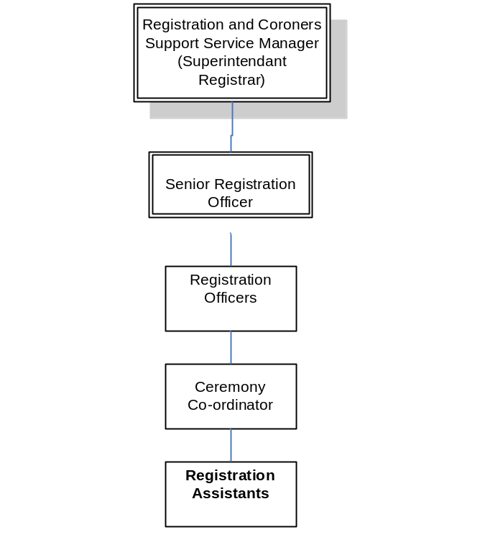

 | Tick relevant level for each category
 | Not applicable | Low | Moderate | High | Very High | Intense | Supporting Information  (if applicable)
PHYSICAL DEMANDS:  Physical Effort and/or Strain – (tiredness, aches and pains over and above that normally incurred in a day to day office environment). |  |  | X |  |  | N/A | Lifting and using step ladders to retrieve and access historic records and registers.  Normal office physical demands.  Walking to and from different venues in the city centre when attending ceremonies.  When multiple ceremonies in the ceremony room at the Guildhall, furniture may need rearranging after use to ensure health and safety standards are maintained and the room is fit for purpose for the next party.
WORKING CONDITIONS:  Working Conditions – (exposure to objectionable, uncomfortable or noxious conditions over and above that normally incurred in a day to day office environment). | X |  |  |  |  | N/A | There are no such conditions to consider.
EMOTIONAL DEMANDS:  Exposure to objectionable situations over and above that normally incurred in a day to day office environment. |  |  | X |  |  |  | Working with customers in sensitive and emotional situations. These range from families who have just suffered a bereavement to emotions involved in occasions such as a wedding ceremony.

PERSON SPECIFICATION |  |  | Tick relevant column |  | List code/s*
The information listed as essential (the column that is shaded) is used as part of the job evaluation process. The requirements identified as desirable are used for recruitment purposes only.  *Codes: AF = Application Form, I = Interview, CQ = Certificate of Qualification, R = References (should only be used for posts requiring DBS), T = Test/Assessment, P = Presentation |  |  | Essential | Desirable | How identified
1. | Qualifications:
1. | 4 GCSE’s grade A to C (including maths and English) or NVQ level 2 or equivalent qualification in related work area. |  | X |  | AF, CQ
2. | Relevant Experience:
2. | A proven track record of commitment to high levels of customer service and experience of dealing with the public in a tactful and sympathetic manner. |  | X |  | AF
2. | Experience of working accurately and methodically and paying particular attention to detail. |  | X |  | AF/I
2. | Experience of working within a busy office environment using multiple IT systems for varying purposes. |  |  | X | AF
3. | Skills (including thinking challenge/mental demands):
3. | Ability to assess situations which are not straightforward and an understanding of when to escalate issues |  | X |  | I
3. | Ability to recognise service failures and identify when these need raising and escalating. |  |  | X | I
3. | Good IT skills, ability to retrieve and input information. |  | X |  | AF
3. | Numeracy skills with ability to maintain accounts and cash sheets. |  | X |  | AF
3. | Accuracy skills, including attention to detail |  | X |  | AF/T
3. | The ability to take a lead and work on one’s own initiative as well as contributing to work as a team. |  | X |  | AF/I
4. | Knowledge:
4. | Basic knowledge of relevant primary legislation: The Births and Deaths Registration act 1953, The Marriage Act 1949, The Civil Partnership Act 2004, The Registration Service Act 1953 and other relevant legislation, statutory regulations, General Register Office policies and procedures in relation to the implementation of these Acts. |  |  | X | AF/I
4. | Basic understanding of issues that affect the delivery of registration services. |  |  | X | I
 | Understanding of issues that can impact on front line service delivery |  | X |  | I
5. | Interpersonal/Communication Skills:  Verbal Skills
5. | Ability to assess situations which are not straightforward and when enquiries should be referred to a supervisor. |  | X |  | I
5. | Excellent communication and advocacy skills, with an ability to deal with customers from a wide range of cultures and backgrounds |  | X |  | I
5. | Co-operates and works well as part of a team, sharing information and supporting others |  | X |  | I
5. | Ability to listen and question to ascertain the needs of the customer in what may be emotional circumstances |  | X |  | AF
5. | Written Skills
5. | Ability to write legibly, neatly and accurately using a fountain pen. |  | X |  | T
5. | Good written skills with the ability to present information clearly and accurately |  | X |  | T/AF
6. | Other:
6. | Awareness of personal responsibilities in dealing with sensitive and confidential issues, with the ability to demonstrate neutrality and remain professional at all times |  | X |  | I
6. | Understands the requirement to maintain confidentiality of manual and computerised records. |  |  | X | AF
6. | Full Driving License and access to own vehicle |  |  | X | AF
6. | Smart appearance, mature and professional attitude |  | X |  | I
6. | Regulation 5 of the Registration of Births, Deaths and Marriages Regulations 1968 (SI 1968/2049) specifies the disqualifications to appointment as a Deputy Registrar:  No person can be appointed in this post if he or she:  - Has been declared bankrupt and has not subsequently obtained his/her discharge, or if he/she is the subject of a bankruptcy restrictions order or an interim order, or if he or she has made any composition or arrangement with his or her creditors and has not subsequently paid of his or her debts in full or obtained a certificate of discharge  - Has been dismissed from any Registration Office and/or the Registrar General does not consent to his or her appointment.  - Is, or has been in the last 12 months preceding the date on which appointment is to take effect, a member of the Council, or of a committee of the council having duties in relation to the appointment of Registration Officers.  - Holds any office as authorised person, secretary (for marriages) of a synagogue or registering officer of the Society of Friends  - Is a minister of religion, a medical practitioner, a midwife, an undertaker or any person involved in a burial or cremation business, a person engaged in any business concerned with life insurance, or a person engaged in any calling which would conflict or prevent proper performance in person of the duties of the office for which he or she is a candidate  - Is an officer or servant of the Council appointed by them to exercise the functions of Proper Officer  Is a Coroner or in an office or servant of a local authority employed by them in the performance of duties relating to their functions as a burial authority. |  | X |  | AF/I
The requirements listed below are not considered during the job evaluation process, but are essential requirements for the role that will be assessed during the recruitment process.
7. |  | Competencies:
 |  | The competencies listed below are all essential requirements for working at Hull City Council in any post; however, those that have been ticked as essential have been identified as key competencies for this role and will be measured as part of the selection process. They are not required to be addressed in the candidate’s application form.
 |  | Leading forward |  | N/A
 |  | Improving services |  | N/A
 |  | Analysis and decision making |  | N/A
 |  | Making things happen |  | N/A
 |  | Communicating with impact |  | N/A
 |  | Collaboration |  | N/A
 |  | Developing self and others |  | N/A
 |  | A copy of the Competency Framework can be accessed via the Council’s website – www.hullcc.gov.uk/jobs
8. |  | Additional Requirements:
 |  | None |  | N/A
9. |  | Disclosure of Criminal Record:
 |  | The successful candidate’s appointment will be subject to the Council obtaining a satisfactory Disclosure from the Criminal Records Bureau (if ticked as an essential requirement). |  |  | DBS Disclosure
 |  | If the postholder requires a DBS disclosure the candidate is required to declare full details of everything on their criminal record. |  | N/A | AF(after short listing)
 |  | If the postholder does not require a DBS disclosure the candidate is required to declare unspent convictions only. | X | N/A | AF(after short listing)

IF THIS IS A NEW OR CHANGED JOB THEN APPENDIX D MUST BE COMPLETED BEFORE SUBMISSION TO THE JOB EVALUATION TEAM

